Примерные варианты ЕГЭ по разделу «Говорение»
Variant 1
1. Imagine that you are preparing a project with your friend. You have found some interesting material for the presentation and you want to read this text to your friend. You have 1,5 minutes to read the text silently, then be ready to read it out aloud. You will not have more than 1,5 minutes to read it.
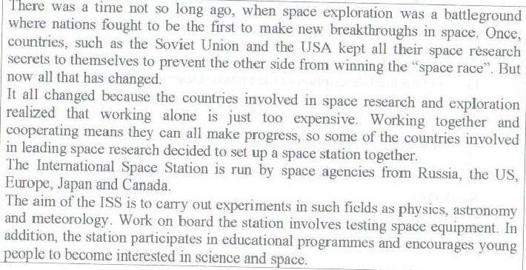
2. Study the advertisement.
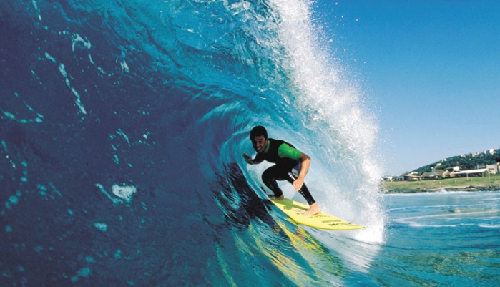
You are taking a language course in Australia. You want to try surfing. You have just found an advertisement to join a local surfing club. You are calling to the club to make some clarifications. In 1,5 minutes you are to ask 5 questions. You have 20 seconds to ask each question.
Find out:
- location of the club
- classes for beginners availability
- personal coach availability
- price for a week
- discounts for students

3. Imagine that while travelling during your holidays you took some photos. Choose one photo to present to your friend. You will have to start speaking in 1,5 minutes and will speak for not more than 2 minutes.
In your talk remember to speak about:
- when you took the picture
- who/what is in the photo
- what is happening
- why you took this photo
- why you decided to show it to your friend
You have to talk continuously, starting with:
I’ve chosen photo number ….
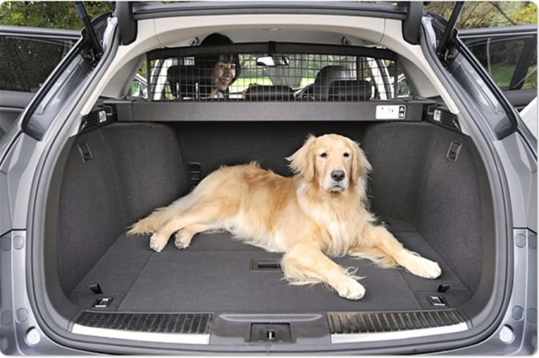 | 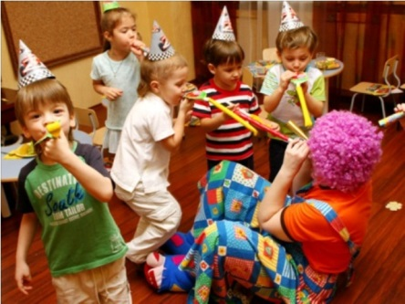 | 

4. Study the two photographs. In 1,5 minutes be ready to compare and contrast the photographs:
- give a brief description of the photos (action, location)
- say what the pictures have in common
- say what differences they have
- say what kind of ski you would prefer with your friend
- explain why
You will speak for not more than 2 minutes. You have to talk continuously.
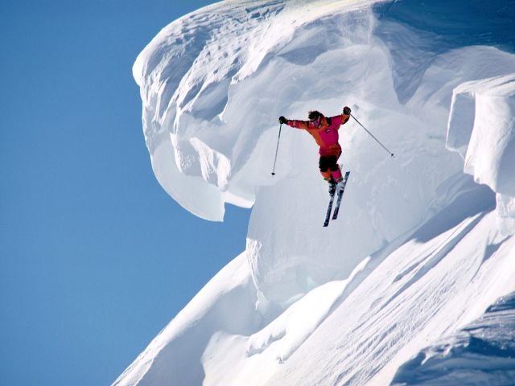 | 

